
FURTHER MATHEMATICS
TRIAL EXAMINATION 2
SOLUTIONS
2013

SECTION A

Core - solutions

Question 1

- There are 70 athletes in the squad
(1 mark)

- Negatively skewed.
(1 mark)

- 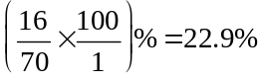 correct to one decimal place.
(1 mark)

Question 2

- 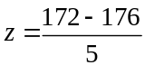
(1 mark)

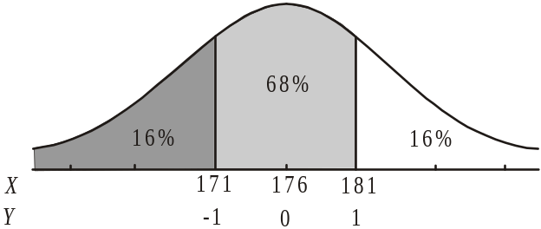

This athlete is 181cm tall which is one standard deviation above the mean.
So 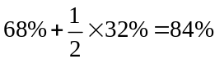 of athletes are shorter.
(1 mark)

Question 3

- The independent variable is weight.
(1 mark)

- Since and by looking at the scatterplot we see that there is a moderate, negative, linear relationship between the variables.
(1 mark)

- 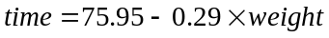
When weight , 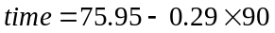
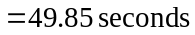
(1 mark)

- The data we have for our 20 athletes includes a maximum weight of about 82kg. To predict a time for a 90kg athlete we therefore have to extrapolate the data and we have no evidence (i.e. no data) to support the least squares equation at this much higher weight.
(1 mark)

- Since 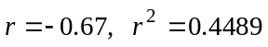
So 45% of the variation in time taken for an athlete to run 400m can be explained by the variation in the weight of the athlete.
(1 mark)

When weight, 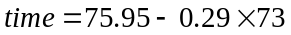
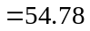
(1 mark)
So the predicted time for an athlete who weighs 73kg is 54.78secs.

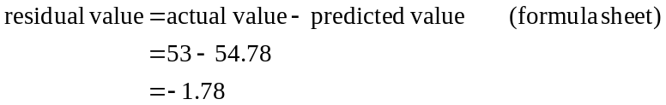
(1 mark)
The residual value is 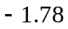seconds. (That is, the least squares regression equation predicted the athlete would run 1.78 seconds slower than she actually did.)

Question 4

- The monthly seasonal indices should add to give 12. (Note that quarterly seasonal indices add to give 4.)
The 11 given indices add to give 10.8. So the September index is 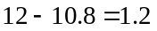
(1 mark)

- 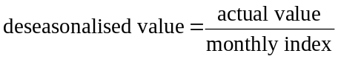
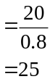
(1 mark)

- The monthly index of 1.2 for July means that the average number of hours spent training by squad members during July is 20% higher than the average number of hours for the twelve months of 2012.
(1 mark)
Total 15 marks

SECTION B

Module 1: Number patterns

Question 1

- 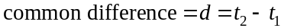
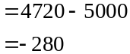

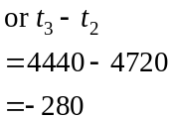
(1 mark)

- Method 1 – generate the sequence
Using CAS, generate the sequence.
In the fifth year, 3 880 copies were published.
(1 mark)

Method 2 – use the formula
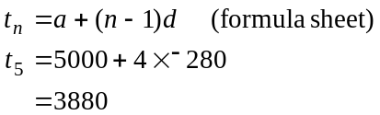
In the fifth year, 3 880 copies were published.
(1 mark)

- 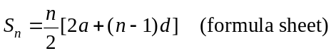
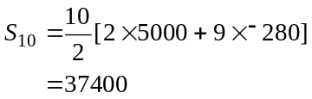
(1 mark)

- Using CAS, generate the sequence.
The number of copies published in the 15th year is 1080.
After this, the number of copies drops below 1000 so the book is published for 15 years.
(1 mark)

- Because the sequence is arithmetic, 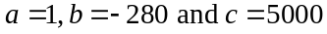

(1 mark) 2 correct answers
(1 mark) 3rd correct answer

Question 2

- 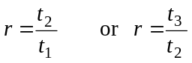
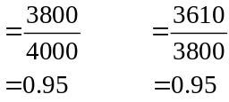

(1 mark)

- Method 1 – generate the sequence.
Using CAS, generate the sequence.
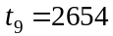 (correct to the nearest whole number)
(1 mark)
Method 2 – using the formula
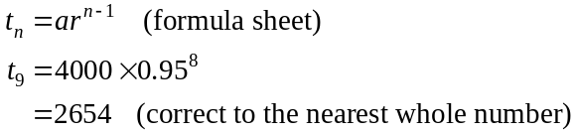
(1 mark)

- Solve 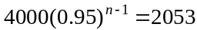 for n

So it was in the 14th year.
(1 mark)

- Solve 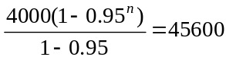 for n.
So it takes 16.5 years (correct to 1 decimal place) for the book to be sold out.
(1 mark)

Question 3

- Using your CAS, generate the sequence.
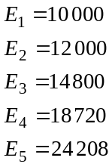
The number of sales in its fifth year is 24 208.
(1 mark)

- i. Generate the sequence.
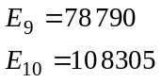
So in the tenth year the number first exceeds 100 000.
(1 mark)
ii. 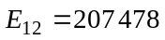
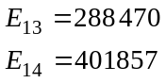
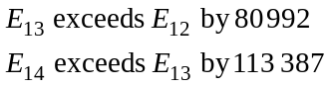
So in the fourteenth year the difference between what was sold in the previous year first exceeds 100 000.
(1 mark)

- Since
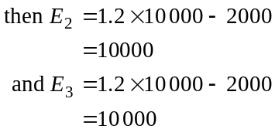
(1 mark)
and so all numbers in the sequence are 10 000 which clearly indicates no growth. If there will be growth.
So m must exceed 1.2.
(1 mark)
Total 15 marks

Module 2: Geometry and trigonometry

Question 1

- 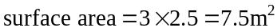
(1 mark)

- In ,
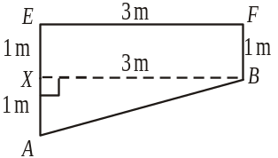

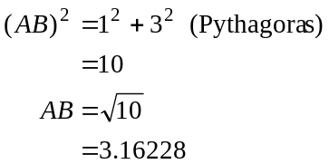
So length of base of pool is 3.2m (correct to 1 decimal place).
(1 mark)

- ,
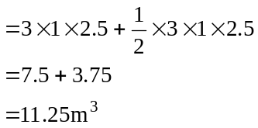
(1 mark)

- From the diagram in part b,
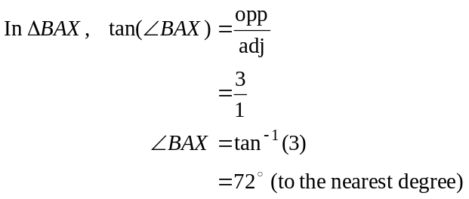
So
(1 mark)

Question 2

- In 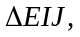
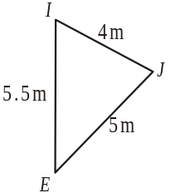
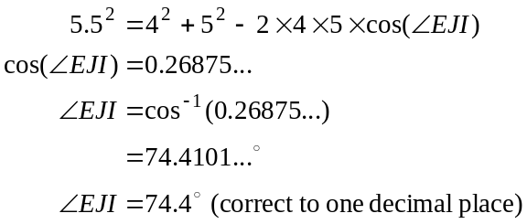
(1 mark)

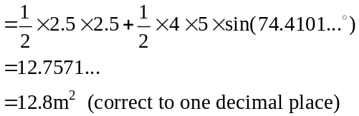
(1 mark) – correct use of sine formula for area
(1 mark) – correct answer
Note that the area of 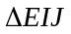 is found using the formula: 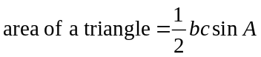.
This formula can be found on the formula sheet.

- 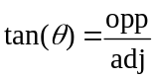
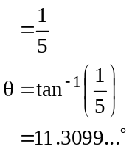
So angle of elevation is 11° to the nearest degree.
(1 mark)

Question 3

- Since 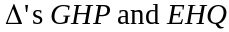 are similar their corresponding side lengths are in the same ratio which is 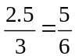 (or 5 : 6). (1 mark)
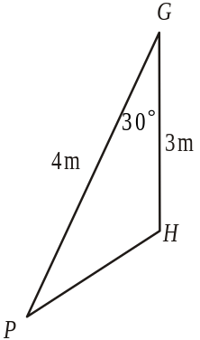
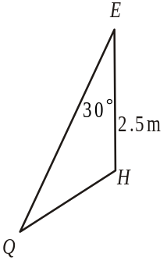

Since the area of 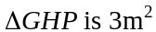, the area of 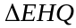 will be
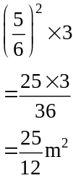
(1 mark)

- Since the are similar 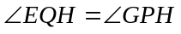.
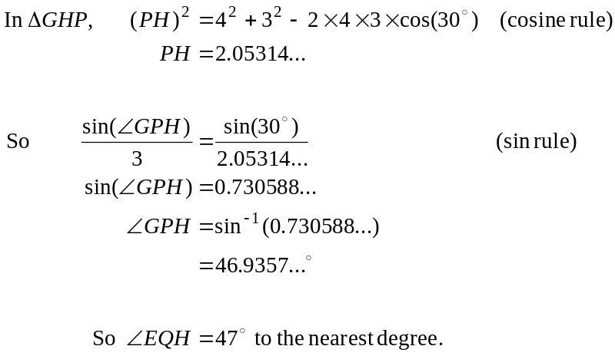
(1 mark)
(1 mark)

Question 4

Solve for MN using CAS
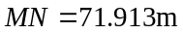 (correct to 3 decimal places)
(1 mark)

- To find the bearing of apartment K from apartment M, first find .
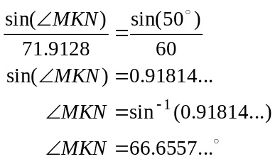
(1 mark)
From the diagram,
(alternate in parallel lines)
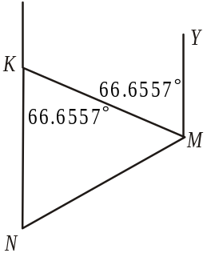
So the bearing of K from M is
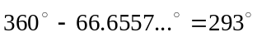 (to the nearest degree)

(1 mark)
Total 15 marks

Module 3: Graphs and relations

Question 1

- 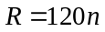
(1 mark)

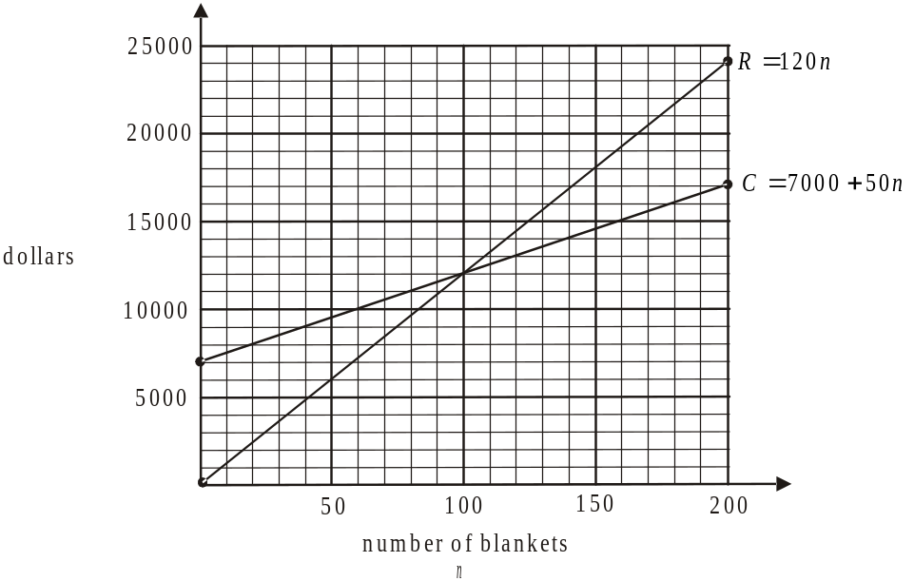

(1 mark)

- Method 1 – using the graph
From the graph the revenue line and the cost line intersect at the point (100, 12 000) so Jane needs to sell 100 blankets to break even.
(1 mark)
Method 2 – algebraically
Break even occurs when
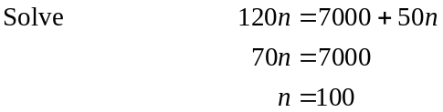
Jane needs to sell 100 blankets to break even.
(1 mark)

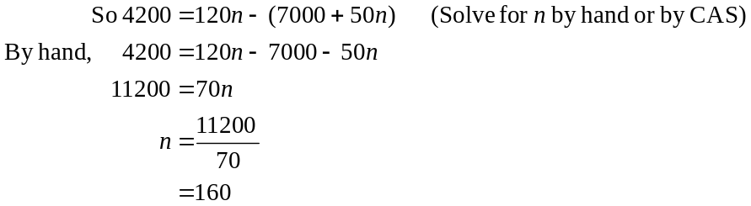
Jane would have sold 160 blankets.
(1 mark)

Question 2

- 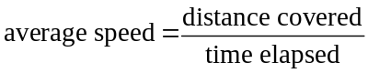
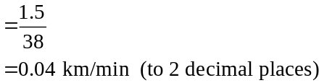
(1 mark)

- Jane was stationary between and then again between . She was stationary for a total of 8 minutes.

(1 mark)

- Jane was walking fastest where the graph is steepest, that is, between.
(1 mark)

- For this section of the graph the y-intercept is 0 so . (1 mark)
For this section of the graph,
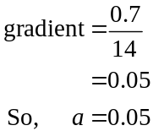
(1 mark)

Question 3

- It takes 35 minutes of machine time to produce a robe.
(1 mark)

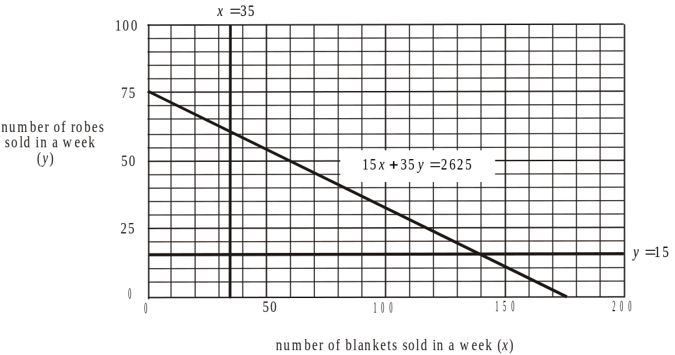

(1 mark)

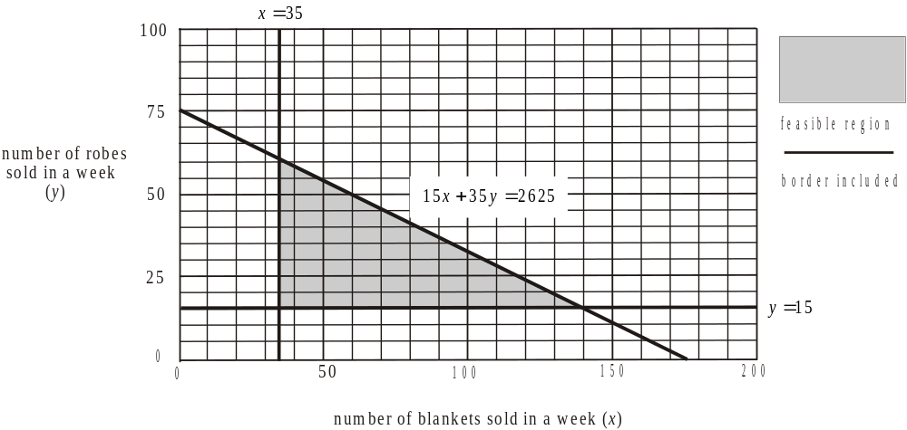

Shade the feasible region on the graph. The maximum number of blankets is given by the x-coordinate of the right-hand corner point of this feasible region.
This point occurs when the lines
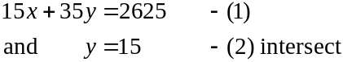
Substitute (2) into (1)
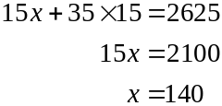
The point is 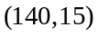.
The maximum number of blankets Jane can sell in a week is 140.
(1 mark)

- The corner points of the feasible region (shown in part c.) are 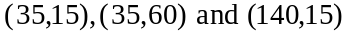.

To find the point and solve for y.

The profit equation is 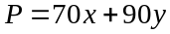.
(1 mark)
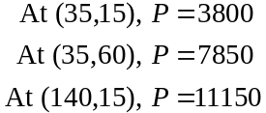

To make a maximum profit, Jane needs to sell 140 blankets and 15 robes.
(1 mark)

- From part d., the maximum profit Jane can make in a week is $11 150.
(1 mark)
Total 15 marks
Module 4: Business-related mathematics

Question 1
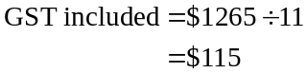

(1 mark)
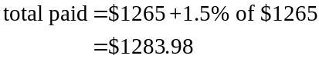

(1 mark)
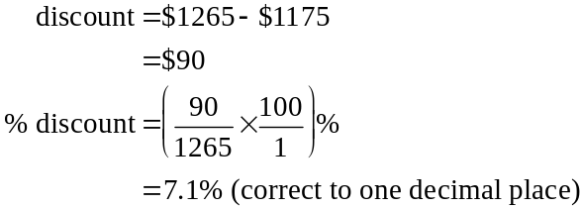

(1 mark)

Question 2
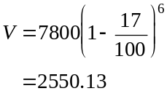

The value after 6 years is $2550.13
(1 mark)

- i. 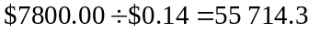
The machine would be written off after producing 55 714 cups of coffee (to the nearest whole number).
(1 mark)

- After 3 years it is expected the machine will have produced 30 000 cups.
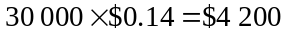.
This is the amount it will have depreciated by so its depreciated value will be
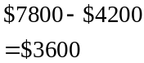
(1 mark)

- Using the flat rate method, the machine depreciates by 20% of 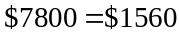 each year. Using the unit cost method, and knowing that 10 000 cups are made each year, the yearly depreciation is 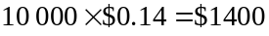 so the flat rate depreciates it by $160 more each year.
(1 mark)

Question 3

- Using the compound interest formula,
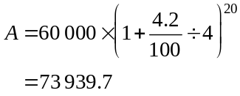
It would be worth $73 939.70. Note that the quarterly interest rate is 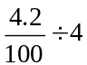 and there are 20 calculations during the investment.
(1 mark)

    - Because there are regular payments being received we can use TVM.

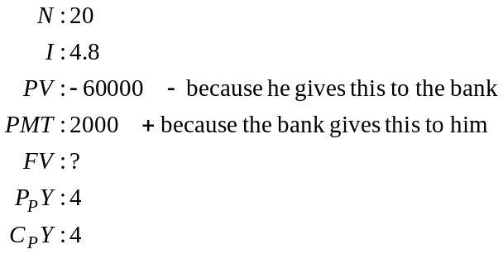
So the future value (i.e. after 5 years) is $31 260.33.
(1 mark)

      - Again using TVM
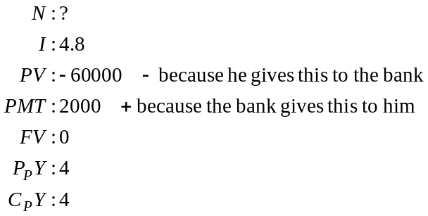
So
It takes 37.413… quarters which means 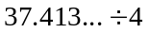 years
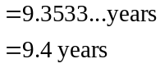
Make sure you answer the question to the correct number of decimal places.
(1 mark)

    - i. The amount he receives per annum is given by
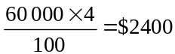
The amount he receives monthly is 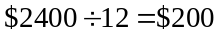.
(1 mark)

- Because this is a perpetuity, the balance remaining is always the original investment i.e. $ 60 000.
(1 mark)

Question 4

- This is a reducing balance loan since regular repayments are to be made.
Using TVM,
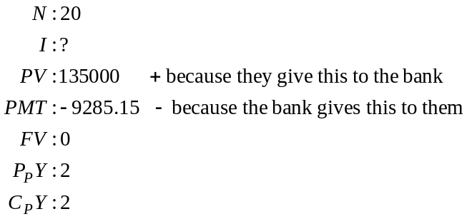
So .
The annual interest rate is 6.5%.
(1 mark)

- i. No payments are made and the amount owing includes the original balance plus the interest due at the end of the first 6 months plus the interest due at the end of the second 6 months which is calculated on the balance which now includes the unpaid interest from the first 6 months. This is an example of compound interest.
So the amount owing is given by
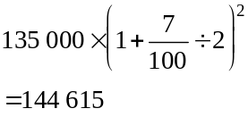
Note that interest is calculated per 6 months so the interest rate is 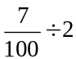.
(1 mark)

ii. The interest is calculated on the amount owing at the end of the first year which is $144 615. This remains constant since the interest is now being paid and not added to the balance owing.
This is an example of simple interest.
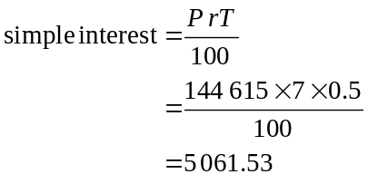
The interest payment to be paid each 6 months is $5061.53.
(1 mark)
Total 15 marks
Module 5: Networks and decision mathematics

Question 1

- Looking at the diagram and using trial and error, the shortest distance goes from the clubhouse via the start of the 11th hole to the start of the 3rd hole to the 5th hole. The total distance is metres.
(1 mark)

- i. To follow a route that passes just once along each edge of the network, the boys will follow an Euler path (the answer to part ii.). The clubhouse vertex and the vertex representing the start of the 5th hole are the only vertices with odd degrees. Hence they are the starting and finishing vertices. The boy finishes therefore at the start of the 5th hole.
(1 mark)

- The route taken is an Euler path.
(1 mark)

- i.
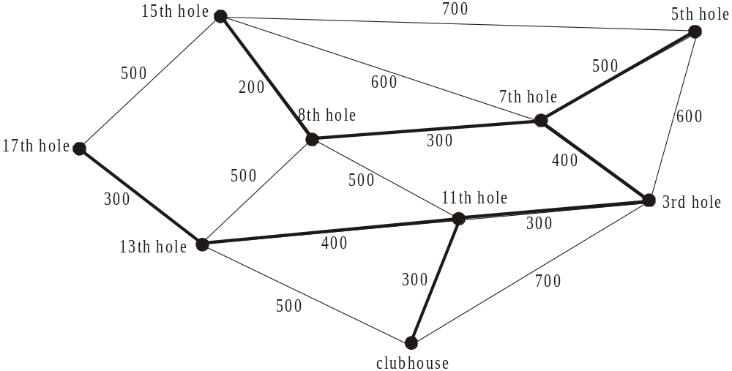

Start with the least value on the edges which is 200 on the edge joining the 8th and 15th holes. Connect the next lowest edge which is 300 that connects to the 7th. The next least is 400 which connects to the 3rd and so on.
(1 mark)

- Adding the totals on the selected edges we get 2700m.
(1 mark)

Question 2

- The missing element

  - in Table 3 is 0. (1 mark)
  - in Table 4 s 4. (1 mark)
  - in Table 5 is 8. (1 mark)

- Using Table 5, create a bipartite graph.

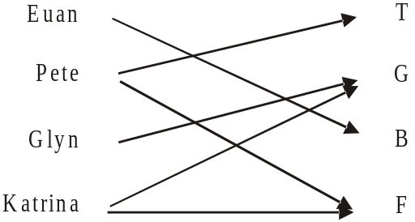

Euan can only do B. Glyn can only do G. Katrina can only do G or F so she gets F. So Pete gets T.
Ground staff | Task
Euan | B
Pete | T
Glyn | G
Katrina | F

(1 mark) – 2 correct allocations
(1 mark) – 2 more correct allocations
Question 3

- The immediate predecessors of activity M are activities G and H. Note that activity G is also an immediate predecessor of activity K. Because two nodes should be connected by just one edge (i.e. G and H can’t both lead to the node preceding activity M) a dummy activity is introduced.
(1 mark)

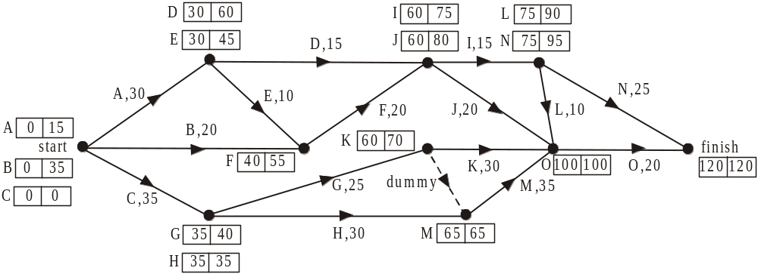

The earliest and latest start times for each of the activities are shown above.
The earliest start time for activity J is 60 minutes.

(1 mark)
- The latest start time for activity A is 15 minutes.
(1 mark)

- The critical path is C, H, M, O.
(1 mark)

- Activity G does not lie on the critical path. It has a slack or float time of 5 minutes. If it is delayed by 15 minutes it will delay the project by 10 minutes. From part d. the minimum time that all 15 activities could be completed in, prior to this delay, was minutes. So the project will now be completed in 130 minutes.
(1 mark)
Total 15 marks

Module 6: Matrices

Question 1

- Order of matrix M is .
(1 mark)

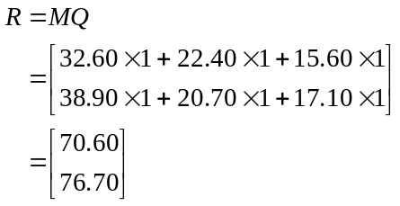

(1 mark)

- Matrix R has two entries. The top entry gives us the cost of purchasing all three products for the watering system at Gunnings ($70.60).
The bottom entry tells us the cost at Pasters ($76.70).
(1 mark)
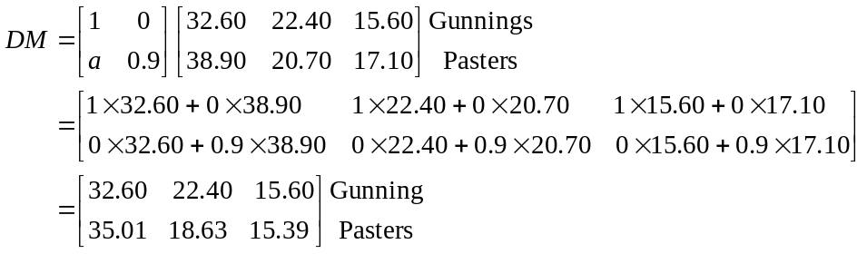

By observing the middle line of the above calculation we see that for the second row of the matrix to give the prices at Pasters with a 10% discount (i.e. 0.9 of the original price), then
(1 mark)

Question 2

- Using matrix A, if George is at Hardwareland, his next stop is Gunnings. If he’s at Gunnings, his next stop is Joe’s. If he’s at Joe’s, his next stop is Pasters.
The order is Gunnings, Joe’s, Pasters.
(1 mark)

- Using the pattern found in part a., if he finished at Hardwareland, he must have started at Gunnings.
(1 mark)

Question 3

- The missing entry in the matrix is 6. The missing entry in the is 148.
(1 mark)

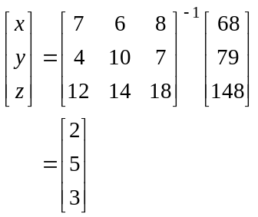

(1 mark)

The cost of a cricket club raffle ticket is $5.
(1 mark)

Question 4

- i. From 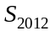, 30 members paid cash in 2012.
Using the transition diagram, 20% of these i.e. 20% of 30 = 6 are expected to pay online the following year in 2013.
(1 mark)
- If a member opts to leave the club then they won’t be renewing the following year hence no arrows lead from L to other options.
(1 mark)

- 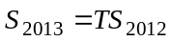

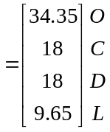 using CAS
(1 mark)

- Using your answer to part b., in 2013, 18 members paid in cash.
(1 mark)
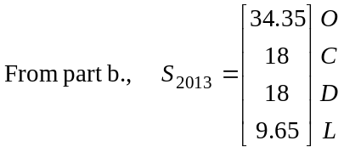

So in 2013 there are 34.35 members paying online and 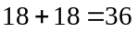paying by other means. Note that 9.65 don’t renew at all.

Using CAS, 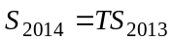
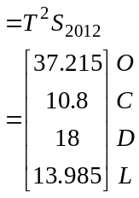
In 2014 there are 37.215 members paying online and paying by other means.
So 2014 is the required year.

(1 mark)
- To investigate the long term, use different values of n.

For example, if 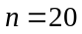,

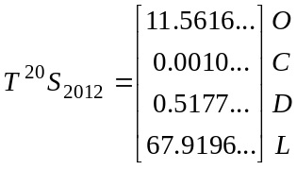

There are still a few members renewing online, virtually none renewing with cash or by direct debit and nearly 68 have let their membership lapse.

If 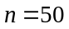,

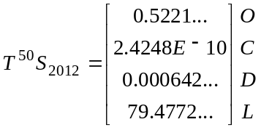
Note that 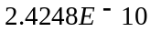 is expressed in standard form and represents the number
0.00000000024248
The first 3 elements in the matrix are approaching zero and the fourth element which corresponds to the number of members who have let their membership lapse, is approaching 80.

So over the long term the number of members at the club will reduce to zero.
(1 mark)
Total 15 marks

